**2022 SAFETY MANUAL**



**Page | 1**

League ID: 207-07-03

Preface

Hello and Thanks for being a part of East Hartford Little League!

It is our mission to provide the safest environment for our athletes to have fun and learn the value of sportsmanship, honesty, loyalty, courage and respect.

A printed form of this document is to be distributed to all active EHLL members. An electronic copy is to be posted on the league’s website and made available for download.

At least one coaching staff member of every team must have a copy of this document with them at all games and practices.

A copy of this document must be kept in clear sight at any operating concession stand and accessible to any volunteer.

A master copy of this document will be kept and maintained by the current league safety officer.

This document will also be submitted to the District Safety Officer, and Little League International, to be approved for use by the local league.

Have a FUN and SAFE Season!

**Page | 2**

TABLE OF CONTENTS

Content Page Emergency ContactList 4   
League Officials ContactList 5   
Safety Rules and Procedures 6

Accident/Injury Reporting 9   
Accident/Injury Form 10   
Accident/Injury Form Instructions 12   
Parent Code of Conduct 13   
Volunteer/Coach Code of Conduct 16   
Player Code of Conduct 19   
Concession Stand Procedures 21   
Volunteer Requirements 26   
VolunteerForm 27   
Concussion Training for Coaches 28   
Facility Survey Requirements 35   
Have a FUN and SAFE season! 40

**Page | 3**

Emergency Contact List

Emergency: 911   
Police: 860-528-4401   
Fire: 860-528-4401   
Poison Control: 860-679-4039  
Ambulance: 860-649-8900   
CT Light & Power(CL&P): 860-947-2000   
Water Management: 860-278-7850   
Parks & Recreation: 860-291-7160   
Hartford Hospital: 860-545-5000   
Children’s Medical Center: 860-545-5000   
Manchester Hospital: 860-646-1222

**Page | 4**

League Officials Contact List

President: Jenilee Tedesco 860-985-1392   
Vice President: Jamie Kershaw

Secretary: Stacey Olmo

Treasurer: Betty Styran  
  
Safety Officer: Joseph Tedesco   
  
Player Agent: Mario Molina

Communications Director: Deanna Bealieau

Baseball Director: ( open position ]

Softball Director: Casey Bealieau

Challengers Director: [ open position ]  
  
Coaching Director: [ open position ]

Equipment Director: Joe Tedesco   
  
Fundraising Director: Morgan Silva

Concessions Director: Corinne Robar 860-803-6033

Social Media Director: Jenilee Tedesco 860-985-1392 **Page | 5**

Safety Rules and Procedures

● All members of East Hartford Little League are responsible forthe safety of the athletes and are expected to follow the rules and procedures of the East Hartford Little League at any practice, game or event.

● All volunteers must fill out and submit the current year’s officialLittle League VolunteerForm. See volunteerrequirements on page 26.

● Team managers willreceive a copy of the current OfficialLittle League rule book, it is required that all teams enforce these rules. A copy of this rule book must be present at every game.

● Team managers are required to be certified in the “Heads Up” concussion training program. Your certificate must be sent to the current Safety Officer.

● At least one coach or managerfrom each team is required to attend our basic first aid training session.

● 2021First aid training session will be held on Thursday April15th from 6pm to 8pm at the East Hartford High School Gymnasium.

● At least one coach or managerfrom each team is required to attend our coaching fundamentals training session provided by the EHLL Coaching Director. ● 2021 Coaching Fundamentals Training session will be held on Thursday April15th from6pm to 8pm at the East Hartford High School Gymnasium.

● Only league approved managers and coaches may practice teams.

● Before each game or practice, coaches and umpires are required to walk the fields looking for hazards and/or unsafe conditions. Report unsafe conditions that can’t be corrected by coaches/umpires immediately to the Safety Officer.

**Page | 6**

Safety Rules and Procedures

(Continued)

● East Hartford Parks and Recreation personnel have jurisdiction overthe town parks, and have the authority to stop, at any time, games or practices if they feel it is not safe.

● No games or practices will be held when the weather orfield conditions are poor, particularly if lighting is inadequate and/orthunderstorms are present.

● Report any field light bulb outages to the Safety Officerimmediately. ● All divisions that allow sliding into bases must have breakaway bases.

● All fields used for practices or games must have a fence topperif a fence is present and less than 12’ high, as well as, a safety track in good condition, and netting to protect players and spectators from foul balls.

● Injuries must be reported to the Safety Officer within 24 hours and all team managers must follow the accident/injury reporting procedures on pages 9-12.

● One First Aid kit and two cold compresses will be provided to each team manager. More will be available at each concession stand as needed. It is required that a first aid kit is present at every practice and game.

● Managers and coaches will neverleave an unattended child during or after a practice or a game.

● The perimeter wooded areas surrounding the baseball fields are off limits to all EHLL participants.

**Page | 7**

Safety Rules and Procedures

(Continued)

● All equipment must be kept in the designated areas within the dugout during games and never be left on the field of play.

● Coaches and Umpires must inspect all equipment before the start of each game or practice to ensure it is in proper working condition and approved for use in Little League games.

● Bats mustremain in their storage area until the batter’s turn to bat. There is no on deck swinging allowed in little league baseball or softball.

● Batters must wear helmets with face guards and catchers must wear, little league approved, complete catchers gear during practices and games. Reduced impact balls are to be used in accordance with Little League Internationals rules and regulations.

● Coaches are not allowed to warm up pitchers or players before or during games.

● Players are not allowed to wear watches,rings, pins, jewelry, or other metallic items during practice and games. Jewelry that alerts emergency personnel to a specific medical condition is permissible but must be taped in place in orderto avoid a possible injury.

● Proper conditioning and stretching should be done before each practice or game.

● A lot of injuries can be prevented by being aware of your surroundings. Teach this to your athletes often, especially in the younger divisions.

● A safety suggestion box will be available at each concession stand. **Page | 8**

**Page | 10**

Accident/Injury Reporting

What to Report:

An incident that causes any player, manager, coach, umpire or volunteerto receive onsite first aid treatment or medical treatment from a medical professional.

When to Report:

All such incidents described above must be reported to the EHLL Safety Officer within 24 hours. Please see page 5 forthe current Safety Officer’s name and contact information.

How to Report:

Call the Safety Officerlisted on page 5 and provide the following information:

● The name and phone number of the individual/s involved, including any witnesses.

● Date, time, and the location of the incident. Be as specific as possible, for example; Gorman park, field 2, home plate.

● A detailed description of the incident, and/orinjury.

● The name and phone number of the person reporting the incident.

You may also print and fill out the “Little League Baseball and Softball Accident Notification Form,” found on page 10 of this manual, the EHLL website; www.ehll.org, or on Little League’s official website; www.littleleague.org. The form must be submitted to the Safety Officer within 24 hours of the incident. See page 12 for more info.

**Page | 11**

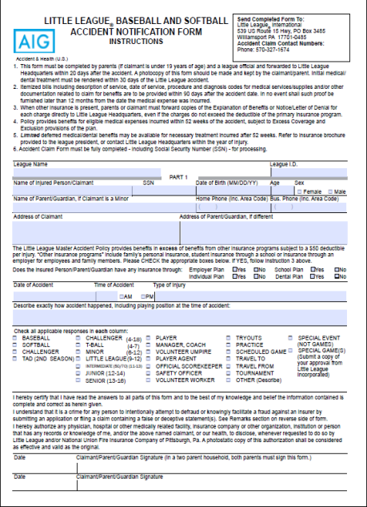**Page | 12**

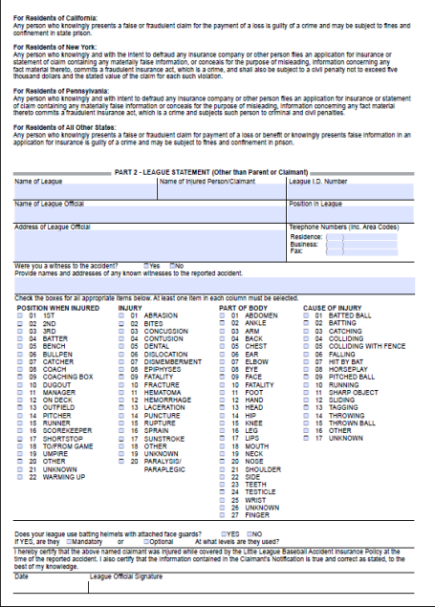**Page | 13**

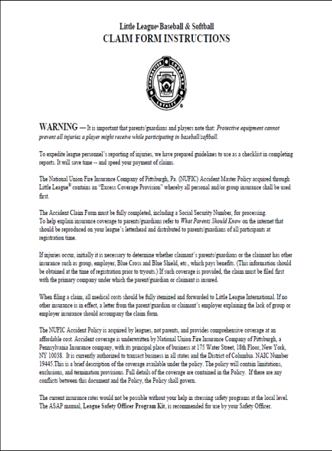**Page | 14**

Parents Code of Conduct

We, the East Hartford Little League, have implemented the following Sport Parent Code of Conduct forthe important message it holds about the properrole of parents in supporting their child in sports. Parents should read and understand this policy priorto their children participating in ourleague.

Any parent guilty of improper conduct at any game or practice will be asked to leave the sports facility and be suspended from the following game. Repeat violations may cause a multiple game suspension, orthe season forfeiture of the privilege of attending all games.

Preamble: The essential elements of character-building and ethics in sports are embodied in the concept of sportsmanship and six core principles: Trustworthiness, Respect, Responsibility,Fairness, Caring and Good Citizenship. The highest potential of sports is achieved when competition reflects these Six Pillars of Character.

I Therefore Agree:

● I will not force my child to participate in sports.

● I willrememberthat children participate to have fun and that the game is for youth, not adults.

● I will inform the coach of any physical disability or ailment that may affect the safety of my child orthe safety of others.

* I will learn the rules of the game and the policies of the league. **Page | 15**

Parents Code of Conduct

(Continued)

I Therefore Agree:

● I (and my guests) will be a positive role model for my child and encourage sportsmanship by showing respect and courtesy, and by demonstrating positive support for all players, coaches, officials and spectators at every game, practice or other sporting event.

● I (and my guests) will not engage in any kind of unsportsmanlike conduct with any official, coach, player, or parent such as booing and taunting; refusing to shake hands; or using profane language or gestures.

● I will not encourage any behaviors or practices that would endangerthe health and well-being of the athletes.

● I will teach my child to play by the rules and to resolve conflicts without resorting to hostility or violence.

● I will demand that my child treat other players, coaches, officials and spectators with respectregardless ofrace, creed, color, sex or ability. ● I will teach my child that doing one’s best is more important than winning, so that my child will neverfeel defeated by the outcome of a game or his/her performance.

● I will praise my child for competing fairly and trying hard, and make my child feel like a winner every time.

**Page | 16**

Parents Code of Conduct

(Continued)

I Therefore Agree:

● I will neverridicule or yell at my child or other participants for making a mistake orlosing a competition.

● I will emphasize skill development and practices and how they benefit my child over winning. I will also deemphasize games and competition in the lower age groups.

● I will promote the emotional and physical wellbeing of the athletes ahead of any personal desire I may have for my child to win.

● I willrespect the officials and their authority during games and will never question, discuss, or confront coaches at the game field, and will take time to speak with coaches at an agreed upon time and place.

● I will demand a sports environment for my child that is free from drugs, tobacco, and alcohol and I willrefrain from their use at all sports events. ● I willrefrain from coaching my child or other players during games and practices, unless I am one of the official coaches of the team.

**Page | 17**





Volunteer/Coach Code of Conduct

We, the East Hartford Little League, have implemented the following Volunteer/Coach Code of Conduct forthe important message it holds about the properrole of Volunteers, Managers and Coaches in Youth Athletics. Volunteers, Managers and Coaches should read and understand this policy priorto volunteering in ourleague.

Any volunteer guilty of improper conduct at any game or practice will be asked to leave the sports facility and be suspended from the following game. The Board of Directors willreview all infractions. Depending on the severity orfrequency, the Board may assess additional disciplinary action up to and including expulsion from East Hartford Little League.

Preamble: The essential elements of character-building and ethics in sports are embodied in the concept of sportsmanship and six core principles: Trustworthiness, Respect, Responsibility,Fairness, Caring and Good Citizenship.

**Page | 18**

No Volunteer, Manager or Coach Shall at Any Time:

● Lay a hand upon, push, shove, strike, orthreaten to strike an official. ● Be guilty of heaping personal verbal or physical abuse upon any official for any real orimaginary belief of a wrong decision orjudgment.

● Be guilty of using unnecessarily rough tactics in the play of a game against the body of an opposing player.

Volunteer/Coach Code of Conduct

(Continued)

No Volunteer, Manager or Coach Shall at Any Time:

● Be guilty of an objectionable demonstration of dissent at an official’s decision by throwing of gloves, helmets, hats, bats, balls, or any otherforceful

unsportsmanlike action.

● Be guilty of a physical attack upon any board member, official manager, coach, player or spectator.

● Be guilty of the use of profane, obscene or vulgarlanguage in any manner at any time.

● Appear on the field of play, stands, or anywhere on the Little League complex while in an intoxicated state. Intoxicated will be defined as an odor or behavior issue.

● Be guilty of gambling upon any play or outcome of any game with anyone at any time.

● Smoke while in the stands or on the playing field orin any dugout. Smoking will only be permitted in designated areas which will be 20 feet from any spectator stands or dugouts.

● Be guilty of publicly discussing with spectators in a derogatory or abusive manner any play, decision or a personal opinion on any players during the game. ● As a manager or coach, be guilty of mingling with orfraternizing with spectators during the course of the game.

● Speak disrespectfully to any manager, coach, official orrepresentative of the league.

**Page | 19**

Volunteer/Coach Code of Conduct

(Continued)

No Volunteer, Manager or Coach Shall at Any Time:

● Be guilty of tampering or manipulating any league rosters, schedules, draft positions or selections, official score books,rankings, financialrecords or procedures.

● Challenge an umpire’s authority. The umpires shall have the authority and discretion during a game to penalize the offender according to the infraction up to and including expulsion from the game.

**Page | 20**

Players Code of Conduct

We, the East Hartford Little League, have implemented the following Player Code of Conduct forthe important message it holds about the proper behavior of players in our League. Players should read and understand this policy priorto participating in our league.

Any player guilty of improper conduct at any game or practice will be asked to leave the sports facility and be suspended from the following game. The Board of Directors will review all infractions. Depending on the severity orfrequency, the Board may assess additional disciplinary action up to and including expulsion from East Hartford Little League.

Preamble: The essential elements of character-building and ethics in sports are embodied in the concept of sportsmanship and six core principles: Trustworthiness, Respect, Responsibility,Fairness, Caring and Good Citizenship. The highest potential of sports is achieved when competition reflects these Six Pillars of Character.

I Therefore Agree:

● I willrememberthat games are played forfun!

● I will display good sportsmanship ahead of my own personal desire to win. ● I will demonstrate good sportsmanship regardless of the score by acting in a positive mannertowards all players, officials, parents and coaches.

**Page | 21**

Players Code of Conduct

(Continued)

I Therefore Agree:

● I will show respect to all game officials, coaches, players, and parents and never act in a mannerthat would be disrespectful toward them.

● I will not use drugs, tobacco or alcohol at any East Hartford Little League practice or game and willremind others on my team not to do so.

● I will shake hands with the otherteam at the conclusion of all games. ● I will shake hands with the officials at the conclusion of all games.

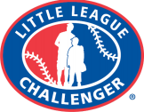

**Page | 22**

Concession Stand Procedures

Concession stand sales are vital to help shoulderthe numerous expenses associated with our programs. With that said, it is important to have a quality product that is safe for public consumption. In orderto ensure the safety of ourfood and our volunteers, we have created this manual, placed it in all of our concession stands and appointed a Concession Stand Director. The Concession Stand Directoris responsible for making sure the following procedures are known and implemented by all volunteers working in our concession stands. You can find the Concession Stand Director’s contact information on page 5 of this manual.

● The current concession stand directoris to have the annual inspection approved by the town’s Health Department priorto the first opening of each season.

● The current concession stand directoris required to obtain or have an active food service certification priorto the first opening of the season. ● All concession stands are required to have, and to check before and after each game/event, thermometers in all cold food and beverage storage containers.

● All volunteers working in our concession stands will be trained in safe food preparation by the current Concession Stand Director, or by a certified trainer. ● All cooking equipment is to be inspected before use and repaired/replaced as needed.

● Only trained workers are allowed to handle propane tanks orlight grills/fryers.

● The EHLL Safety Manual must be displayed in every concession stand. **Page | 23**

Concession Stand Manual

(Continued)

● An MSDS (Material Safety Data Sheets) book must be maintained and easily accessible by all volunteers. There must be an MSDS for every cleaning chemical used in the concession stand.

● All cleaning chemicals must be labeled and stored in a closed container away from food and cooking equipment.

● All concession stand workers must wash their hands before and after handling food. See page 23 fortraining on proper hand washing. ● All concession stand workers must wearfood grade disposable gloves when handling ready to serve food.

● An annually inspected certified fire extinguisher must be present in every concession stand and all concession stand volunteers trained in their use. See page 24 for PASS fire extinguishertraining.

● All concession stands are to post the emergency contact list, the league officials contact list, an MSDS book, and the current year’s EHLL Safety Manual in a conspicuous area for anyone to access during operation.

● A fully stocked first aid kit must be present at every concession stand. ● Extra ice packs, coach’s first aid kits, and current yearlittle league rule books are to be kept in stock at every concession stand.

● No one underthe age of15 is allowed to operate any food producing/cooking equipment.

● Each year’s menu items are to be approved by the Concessions Director, the Safety Officer, and the President of EHLL. The approved menu items are to be posted in this manual, see page 25.

**Page | 24**

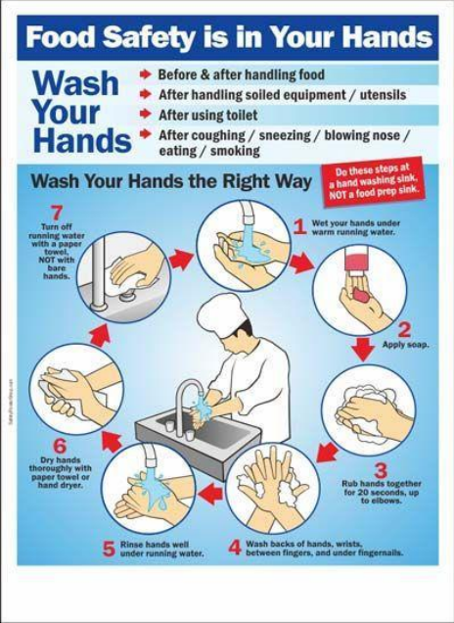**Page | 25**

**Page | 26**

**Page | 27**

Volunteer Requirements

East Hartford Little League is an entirely volunteerrun, non-profit organization. It is the hard working parents and community volunteers that make EHLL work. They do everything from coaching, scheduling, ordering uniforms, working the concession stands, to serving as board members. Since 1950, our volunteers’ hard work has been the reason Little League continues to provide quality team sports for our youth.

All volunteers must fill out a Little League Volunteer Application and supply a photocopy of a valid government issued photo identification. A national sex offenders and criminal background check will be performed on all volunteers, every year – even forreturning volunteers. Anyone refusing to fill out a volunteerform will be ineligible to volunteer. These forms are kept confidential by the league president and are retained forthe volunteer’s entire year of service.

Volunteers will be defined as; Board of Directors, Umpires, Managers of Teams, Coaches, Assistant Coaches, Team Moms, Concession Stand Operators, anyone that provides a service to the league that places them in direct contact with players, and anyone that has repetitive access or contact with players.

Please see Page 27for an example of the Volunteer Application.

**Page | 28**

**Page | 29**

Concussion Training for Coaches

East Hartford Little League requires all Head Coaches to provide a certificate of completion forthe CDC’s HEADS UP concussion training for Youth Sports Coaches. It is an online course that takes about 3 hours to complete. The Safety Officer will be responsible fortracking and enforcing compliance. The Safety Officer will communicate with you if you are required to take the training but it is suggested that all volunteers take the training. The online training course can be found by going to:

https://www.cdc.gov/headsup/resources/training.html

Please see additional concussion training on pages 29 through 33. 

One of the main jobs of a youth sports coach is keeping athletes safe. This sheet has information to help you protect athletes from concussion or other serious brain injury, learn how to spot a concussion, and know what to do if a concussion occurs.

**Page | 30**

****WHAT IS A CONCUSSION?



A concussion is a type of traumatic brain injury—or TBI— caused by a bump, blow, orjolt to the head or by a hit to the body that causes the head and brain to move quickly back and forth. This fast movement

can cause the brain to bounce around ortwist in the skull, creating chemical changes in the brain and

sometimes stretching and damaging the brain cells.

HOW CAN I HELP KEEP ATHLETES SAFE?



Sports are a great way for children and teens to stay healthy and can help them do well in school. As a

youth sports coach, your actions create the culture for safety and can help lower an athlete’s chance of getting a concussion or other serious injury. Aggressive and/or unsportsmanlike behavior among

athletes can increase their chances of getting a concussion or other serious injury. Here are some ways you can help keep your athletes safe:

Talk with athletes about the importance ofreporting a concussion:

• Talk with athletes about any concerns they might have aboutreporting their concussion symptoms.

Make sure to tell them that safety comes first and you expect them to tell you and their parent(s) if

they think they have a concussion.

Create a culture of safety at games and practices:

• Teach athletes ways to lowerthe chances of getting a concussion.

• Enforce the rules of the sport forfair play, safety, and sportsmanship.

• Ensure athletes avoid unsafe actions such as:

› Striking another athlete in the head;

› Using their head or helmet to contact another athlete;

› Making illegal contacts or checking, tackling, or colliding with an unprotected opponent; and/or

› Trying to injure or put another athlete atrisk forinjury.

• Tell athletes that you expect good sportsmanship at all times, both on and off the playing field.

Keep up-to-date on concussion information:

• Review your state, league, and/or organization’s concussion guidelines and protocols.

• Take a training course on concussion. CDC offers concussion training at no cost at

www.cdc.gov/HEADSUP.

• Download CDC’s HEADS UP app or a list of concussion signs and symptoms that you can keep on hand. Check out the equipment and sports facilities:

**Page | 31**

• Make sure all athletes wear a helmet that fits well and is in good condition when appropriate forthe sport or activity. There is no “concussion-proof” helmet, so it is important to enforce safety rules that protect athletes from hits to the head and when a helmet falls off during a play.

• Work with the game or event administratorto remove tripping hazards and ensure that equipment, such as goalposts, have padding that is in good condition.

Keep emergency contact information handy:

• Bring emergency contact information for parents and health care providers to each game and practice in case an athlete needs to be taken to an emergency departmentright away for a concussion or other serious injury.

• If firstresponders are called to care for an injured athlete, provide them with details about how the injury happened and how the athlete was acting afterthe injury.

HOW CAN I SPOT A POSSIBLE CONCUSSION?



Athletes who show orreport one or more of the signs and symptoms listed below—or simply say they just “don’t feelright” after a bump, blow, orjolt to the head or body—may have a concussion or other serious brain injury.

SIGNS OBSERVED BY COACHES OR PARENTS:

• Appears dazed or stunned.

• Forgets an instruction, is confused about an assignment or position, oris unsure of the game, score, or opponent.

• Moves clumsily.

• Answers questions slowly.

• Loses consciousness (even briefly).

• Shows mood, behavior, or personality changes.

• Can’trecall events priorto or after a hit orfall.

SYMPTOMS REPORTED BY ATHLETES:

• Headache or“pressure” in head.

• Nausea or vomiting.

• Balance problems or dizziness, or double or blurry vision.

• Bothered by light or noise.

• Feeling sluggish, hazy, foggy, or groggy.

• Confusion, or concentration or memory problems.

• Just not “feeling right”, or“feeling down”.

NOTE: Concussion signs and symptoms often show up soon afterthe injury, but it can be hard to tell how serious the concussion is at first. Some symptoms may not be noticed or may not show up for hours or days.

WHAT ARE SOME MORE SERIOUS DANGER SIGNS TO LOOK FOR?

**Page | 32**



In rare cases, a dangerous collection of blood (hematoma) may form on the brain after a bump, blow, or jolt to the head or body and can squeeze the brain against the skull. Call 9-1-1 or ensure an athlete is taken to the emergency departmentright away if, after a bump, blow, orjolt to the head or body, he or she has one or more of these danger signs:

• One pupil largerthan the other.

• Drowsiness orinability to wake up.

• A headache that gets worse and does not go away.

• Slurred speech, weakness, numbness, or decreased coordination.

• Repeated vomiting or nausea, convulsions or seizures (shaking ortwitching). • Unusual behavior, increased confusion,restlessness, or agitation.

• Loss of consciousness (passed out/knocked out). Even a brief loss of consciousness should be taken seriously.

| CONCUSSIONS AFFECT EACH ATHLETE DIFFERENTLY.  While most athletes with a concussion feel better within a couple of weeks, some will have symptoms for months orlonger. Talk with an athlete’s parents if you notice their concussion symptoms come back afterthey return to play. |
| --- |

WHAT SHOULD I DO IFI THINK AN ATHLETE HAS A POSSIBLE CONCUSSION? 

As a coach, if you think an athlete may have a concussion, you should:

REMOVE THE ATHLETE FROM PLAY.

When in doubt, sit them out!

KEEP AN ATHLETE WITH A POSSIBLE CONCUSSION

OUT OF PLAY ON THE SAME DAY OF THE INJURY AND UNTIL CLEARED BY A HEALTH CARE PROVIDER. Do not try to judge the severity of the injury yourself. Only a health care provider should assess an athlete for a possible concussion. After you remove an athlete with a possible concussion from practice or play, the decision aboutreturn to practice or play is a medical decision that should be made by a health care provider. As a coach,recording the following information can help a health care providerin assessing the athlete afterthe injury:

• Cause of the injury and force of the hit or blow to the head or body.

• Any loss of consciousness (passed out/knocked out) and if so, for how long.

• Any memory loss right afterthe injury.

• Any seizures right afterthe injury.

• Number of previous concussions (if any).

INFORM THE ATHLETE’S PARENT(S) ABOUT THE POSSIBLE CONCUSSION.

**Page | 33**

Let them know about the possible concussion and give them the HEADS UP fact sheet for parents. This fact sheet can help parents watch the athlete for concussion signs or symptoms that may show up or get worse once the athlete is at home orreturns to school.

ASK FOR WRITTEN INSTRUCTIONS FROM THE ATHLETE’S HEALTH CARE PROVIDER ON RETURN TO PLAY. These instructions should include information about when they can return to play and what steps you should take to help them safely return to play.

WHY SHOULD I REMOVE AN ATHLETE WITH A POSSIBLE CONCUSSION FROM PLAY? 

The brain needs time to heal after a concussion. An athlete who continues to play with concussion has a greater chance of getting another concussion. A repeat concussion that occurs while the brain is still healing from the first injury can be very serious and can affect an athlete for a lifetime. It can even be fatal.

| SOME ATHLETES MAY NOT  REPORT A CONCUSSION  BECAUSE THEY DON’T THINK A CONCUSSION IS SERIOUS.  They may also worry about: |
| --- |
|  |
| • Losing their position on the team or during the game.  • Jeopardizing theirfuture sports career.  • Looking weak.  • Letting theirteammates orthe team down.  • What their coach orteammates might think of them. |

WHAT STEPS CAN I TAKE TO HELP AN ATHLETE RETURN TO PLAY?



An athlete’s return to school and sports should be a gradual process that is approved and carefully managed and monitored by a health care provider. When available, be sure to also work closely with yourteam’s certified athletic trainer.

Below are five gradual steps that you, along with a health care provider, should follow to help safely return an athlete to play. Remember, this is a gradual process. These steps should not be completed in one day, but instead over days, weeks, or months.

BASELINE:

Athlete is back to theirregular school activities, is no longer experiencing symptoms from the injury when doing normal activities, and has a green light from their health care providerto begin the return to play process.

**Page | 34**

An athlete should only move to the next step if they do not have any new symptoms at the current step.

STEP 1:

Begin with light aerobic exercise only to increase an athlete’s heartrate. This means about 5 to 10 minutes on an exercise bike, walking, orlight jogging. No weightlifting at this point.

STEP 2:

Continue with activities to increase an athlete’s heartrate with body or head movement. This includes moderate jogging, briefrunning, moderate-intensity stationary biking, and moderate-intensity weightlifting (less time and/orless weight than a typicalroutine).

STEP 3:

Add heavy non-contact physical activity, such as sprinting/running, high-intensity stationary biking, regular weightlifting routine, non-contact sport-specific drills (in 3 planes of movement).

STEP 4:

An athlete may return to practice and full contact (if appropriate forthe sport) in controlled practice.

STEP 5:

An athlete may return to competition.

REMEMBER:

It is important for you and the athlete’s parent(s) to watch for concussion symptoms after each day’s return to play progression activity. If an athlete’s concussion symptoms come back, or he or she gets new symptoms when becoming more active at any step, this is a sign that the athlete is pushing him- or herself too hard. The athlete should stop these activities, and the athlete’s health care provider should be contacted. Afterthe okay from the athlete’s health care provider, the athlete can begin at the previous step.

**Page | 35**

Facility Survey Requirements

The Safety Officeris required to complete the annualLittle League Facility Survey in the Little League Data Center.

A few things to always remember:

● Before every practice or game, the playing fields are to be walked/inspected by Coaches and Umpires.

● A first aid kit is required to be present at all practices and games. ● A copy of this manual is to be present at every practice or game. ● A copy of this manual must be clearly posted in every concession stand. ● Emergency and Key League Officials contact information is to be clearly posted in all concession stands.

● The East Hartford Parks and Rec department has the final say whether or not the fields are safe for use.

● The wooded areas surrounding ballparks are off limits to all EHLL players and personnel during any EHLL events.

The following paper surveys are to be used and retained in orderto complete the annual Little League Facility Survey online in the Little League Data Center:



**Page | 36**

**Page | 37**

**Page | 38**

**Page | 39**

**Page | 40**

**Page | 41**

Have A FUN and SAFE Season!

**Page | 42**

**Page | 43**